**ANSWER:**

**Solution**

Agile and Waterfall are both two distinct software project management techniques with different approaches, Basic definition of both are given below:

**Agile** is used for describing ways of planning and doing work in which it is understood that making changes as they are needed is an important part of the job.

**Waterfall** The waterfall project management approach entails a clearly defined sequence of execution with project phases that do not advance until a phase receives final approval. Once a phase is completed, it can be difficult and costly to revisit a previous stage.

**Waterfall Methodology Phases:**

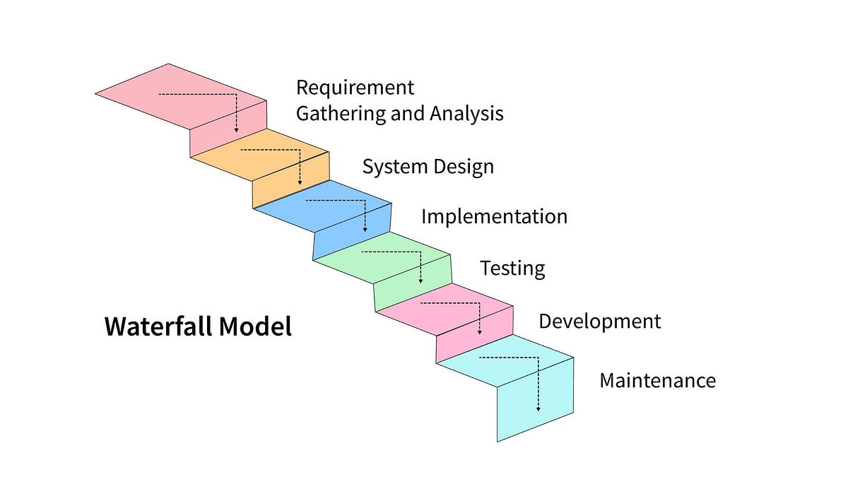

1. **Requirements Gathering and Analysis**
   * All project requirements are gathered upfront to understand the project's scope and objectives.
2. **System Design**
   * The overall system architecture and design specifications are created based on requirements.
3. **Implementation (Coding)**
   * Developers start coding based on the design specifications, and the product is built in this phase.
4. **Testing**
   * The completed product is tested against the requirements to identify defects and ensure it meets specifications.
5. **Deployment**
   * The final product is deployed to the production environment and made available to the users.
6. **Maintenance**
   * After deployment, the product undergoes maintenance, which includes fixing bugs, making updates, and providing ongoing support.

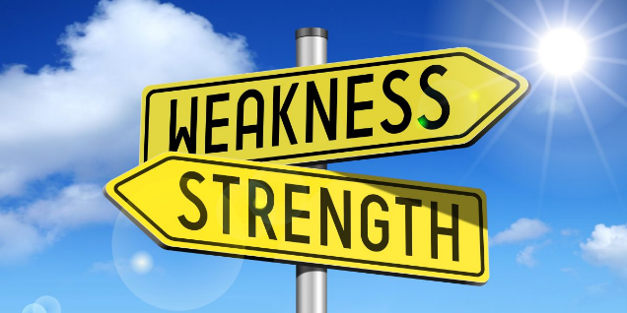**Strengths:**

* Clear Structure and Documentation
* Easier to Manage Predictable Projects
* Well-Suited for High-Complexity Projects
* Easy Handoff and Onboarding

**Weaknesses:**

* Inflexibility to Change
* Late Testing and Feedback
* Minimal Customer Involvement After Requirements Gathering
* Long Delivery Times

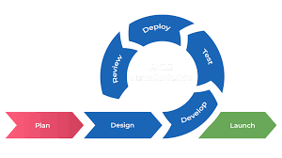**Agile Methodology Phases**

1. **Concept and Initiation**
   * The project vision, goals, and initial requirements are defined. User stories or a product backlog are created to prioritize features.
2. **Planning**
   * Sprint planning takes place, where the team selects specific features (user stories) to be completed in the upcoming sprint cycle.
3. **Iteration (Sprint)**
   * Development occurs in cycles, typically 2-4 week sprints. Each sprint includes development, testing, and review of selected features, delivering a potentially shippable product increment.
4. **Testing**
   * Testing is continuous, with testing and quality checks integrated into each sprint to catch and resolve issues early.
5. **Review** 
   * At the end of each sprint, a review is conducted to assess completed work, followed by a retrospective to discuss improvements for the next cycle.
6. **Release**
   * A release occurs after several sprints, delivering a more complete and functional product to users.
7. **Maintenance**
   * After deployment, the Agile team continues to support, maintain, and enhance the product based on user feedback.



**Strengths:**

* Flexibility and Adaptability
* Continuous Feedback and Improvement
* Faster Time to Market
* High Customer Satisfaction

**Weaknesses:**

* Requires Close Collaboration and High Commitment
* Can Lead to Scope Creep
* Documentation May be Lacking
* Difficult to Predict Project Timelines and Budgets

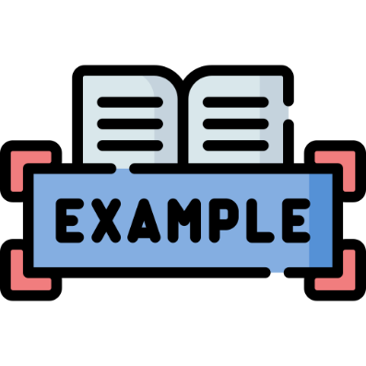

**Real-World Examples**

**Waterfall Methodology:**

**NASA's Apollo Missions (Success)**

* **Context:** In the 1960s, NASA's Apollo missions were highly complex projects with clear goals (landing on the moon) and non-negotiable requirements. The Waterfall model provided a structured, phase-by-phase approach with heavy documentation and stringent testing, ideal for such a high-stakes environment.
* **Outcome:** Waterfall’s predictability and sequential nature helped ensure all mission requirements were addressed before launch, contributing to the Apollo program's success.

**Denver International Airport Baggage System (Challenges)**

* **Context:** In the early 1990s, Denver attempted to automate its airport baggage system using Waterfall. However, the project faced a constantly evolving scope due to changes in airport design and functionality.
* **Outcome:** The inability to adapt to changes led to significant delays, cost overruns, and ultimately a failed system that was eventually abandoned, highlighting Waterfall's limitations in dynamic environments.

**Agile Methodology:**

**Spotify’s Continuous Delivery (Success)**

* **Context:** Spotify uses Agile to develop and release new features quickly in response to user feedback. Teams work independently in “squads” to deliver incremental updates.
* **Outcome:** Agile iterative nature allows Spotify to adapt to user needs rapidly, delivering frequent updates that improve the user experience and keep the platform competitive.

**Healthcare.gov Initial Launch (Challenges)**

* **Context:** The U.S. government’s healthcare marketplace website attempted to implement Agile without fully adhering to Agile principles (e.g., lack of team collaboration and feedback cycles).
* **Outcome:** The initial rollout faced severe performance and usability issues, illustrating the challenges of Agile when not fully committed to its practices, especially in a complex environment with multiple stakeholders.

**Scenarios and Suitability**

**When Waterfall Might Be More Suitable:**

* **Highly Regulated Industries:** Projects in fields like healthcare, government, or aerospace often have rigid requirements and compliance needs, making Waterfall’s structured approach ideal.
* **Fixed Requirements and Budget:** Projects with clear, unchanging requirements, defined budgets, and deadlines benefit from Waterfall, where the upfront planning provides greater control.

**When Agile Might Be More Suitable:**

* **Customer-Centric Product Development:** For projects where customer feedback is crucial (e.g., mobile app development), Agile allows for fast iterations based on real-time user input.
* **Innovative or Evolving Projects:** Agile is ideal for projects in tech industries where requirements are likely to evolve and where adaptability is key, such as in startups or SaaS development.

**QUESTION # 02**

**ANSWER:**

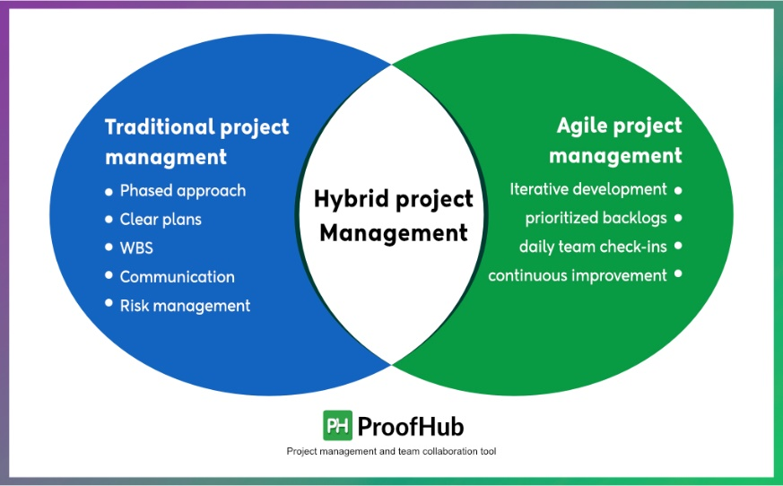**Project Management Strategy for a Hybrid Software Development Project**

**1. Project Background and Objectives**

In a complex software development project, such as the development of a comprehensive **E-Commerce platform**, both traditional (Waterfall) and agile methodologies have distinct advantages. The objective is to leverage both to address predictable, well-defined requirements (Waterfall) and adapt to evolving requirements (Agile) that may emerge due to user feedback or changes in market demand. A hybrid approach, often referred to as "Agile-Waterfall," enables the team to benefit from the structured planning of Waterfall while retaining Agile adaptability and responsiveness.

**2. Project Management Strategy and Technique Integration**

**Phase 1: Planning and Requirement Gathering (Traditional/Waterfall)**

* **Techniques Used**: Waterfall for initial stages, Requirement Engineering of project.
* **Justification**: Waterfall structured approach is well-suited for defining core requirements. This phase can begin with comprehensive requirement engineering sessions to document high-level functionality. For example: core modules like Product Listings, Order Processing, Payment Gateway.
* **Benefits**: Provides clear, foundational project scope. High-level design decisions allow for setting up initial timelines, resource allocation, and budget, crucial for a project with many stakeholders.

**Phase 2: Design and Architecture (Traditional with Agile Iterations)**

* **Techniques Used**: System architecture design (Waterfall), iterative design sprints (Agile).
* **Justification**: Use traditional methods for establishing the platform’s base architecture, while Agile iterative approach can refine specific modules based on stakeholder input. For example, the product listing module can be iteratively designed, reviewed, and revised.
* **Benefits**: Allows detailed planning of the core infrastructure while iteratively adjusting individual components to meet evolving needs.

**Phase 3: Development (Agile for Customer-Facing Modules; Waterfall for Backend Stability)**

* **Techniques Used**: Agile Scrum for frontend/customer-facing components, Waterfall for backend core systems.
* **Justification**: Agile Scrum teams handle frontend features (user interface and experience), allowing rapid feedback integration. Waterfall suits backend components, where stability, security, and compliance are critical and where changes may have extensive ripple effects.
* **Benefits**: Maximizes flexibility in user-facing areas, responding quickly to user feedback and market demands, while maintaining backend reliability.

**Phase 4: Testing and Quality Assurance (Hybrid of Agile Testing and Traditional QA)**

* **Techniques Used**: Continuous Integration/Continuous Deployment (CI/CD) for Agile modules, rigorous Waterfall-style QA for backend.
* **Justification**: Agile testing (e.g., test-driven development and CI/CD) can be applied to customer-facing modules to ensure prompt bug fixes and incremental updates. In contrast, the backend requires comprehensive testing with longer test cycles for stress, security, and performance.
* **Benefits**: Ensures high-quality, stable product delivery while maintaining rapid testing cycles for the frontend and rigorous backend verification.

**Phase 5: Deployment and Maintenance (Agile for Updates, Waterfall for Major Releases)**

* **Techniques Used**: Agile sprints for incremental updates, Waterfall for planned major version releases.
* **Justification**: The Agile approach supports iterative updates, allowing continuous feature enhancements and bug fixes. Major releases with significant backend changes follow Waterfall to ensure all components are stable before a large rollout.
* **Benefits**: Supports continuous improvement and incremental feature release while mitigating risks associated with large-scale updates.

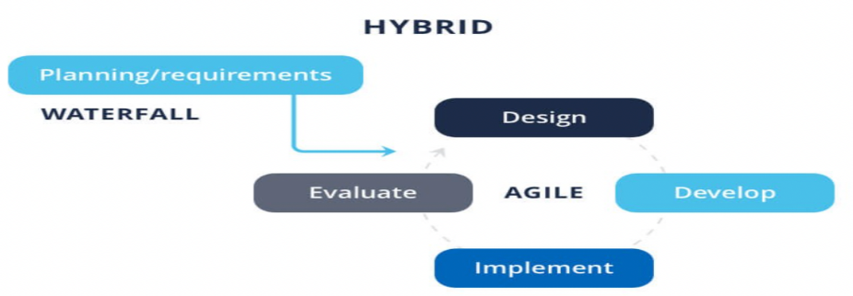

**3. Challenges of Implementing a Hybrid Approach**

* **Challenge 1**: **Communication and Coordination**
  + **Description**: Balancing teams using different methodologies may lead to miscommunication and challenges in aligning goals.
  + 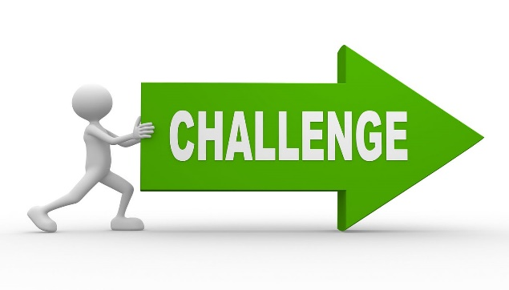**Mitigation Strategy**: Use a project management tool (e.g., Jira) for centralized tracking, and implement regular cross-functional meetings. Designating a project coordinator or Scrum Master who understands both methodologies can bridge gaps between teams.
* **Challenge 2**: **Balancing Agile Flexibility with Waterfall’s Rigidity**
  + **Description**: Agile flexible iteration cycles can clash with Waterfall’s rigid structure.
  + **Mitigation Strategy**: Define "release boundaries" where Agile iterations are paused to align with the Waterfall timeline. This provides structure while allowing flexibility within specified boundaries.
* **Challenge 3**: **Resource Allocation and Task Prioritization**
  + **Description**: Hybrid projects often require dual expertise, and task prioritization may become ambiguous.
  + **Mitigation Strategy**: Assign a product owner to manage feature prioritization and a technical lead to other resources. Agile prioritization techniques can help prioritize tasks effectively without disrupting the traditional timeline.

**4. Industry Best Practices and Case Studies**

* **Case Study**: **IBM’s Hybrid Approach** — IBM often employs a hybrid project management approach for large-scale enterprise projects, particularly in its complex service integrations. By using Agile methodologies for customer-facing updates and Waterfall for infrastructure changes, IBM balances rapid deployment with long-term stability.
* **Case Study**: **Spotify** — Known for its "Agile Waterfall" approach, Spotify applies Agile for product features and iterative updates. The backend relies on a more structured, Waterfall-like approach to maintain stability and reliability in user data management.
* **Best Practice**: **Scaled Agile Framework (SAFe)** — Companies like Intel and Cisco utilize SAFe to implement Agile at an enterprise scale while retaining elements of Waterfall. SAFe combines traditional planning with Agile flexibility, promoting smooth transitions and collaboration across complex, multi-phase projects.

**5. Conclusion**

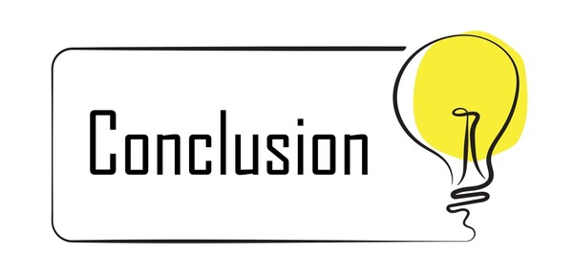A hybrid approach that integrates Agile and Waterfall methodologies can be highly effective for complex projects, offering a balanced mix of structure and adaptability. Each methodology complements the other, ensuring that both stable core functionality and user-responsive features can be achieved without compromising quality or project timelines. By identifying potential challenges and proactively establishing mitigation strategies, teams can enhance the efficacy and success of their hybrid projects.  
  
**REFERENCES:**

[1] <https://www.productplan.com/learn/agile-vs-waterfall/>

[2] <https://www.simplilearn.com/tutorials/agile-scrum-tutorial/agile-vs-waterfall>

[3] <https://www.forecast.app/blog/difference-between-agile-waterfall>

[4] <https://www.geeksforgeeks.org/agile-vs-waterfall/>

[5] <https://kvytechnology.com/blog/software/agile-case-studies/>

[6]<https://www.researchgate.net/publication/377434258_COMPREHENSIVE_REVIEW_OF_AGILE_METHODOLOGIES_IN_PROJECT_MANAGEMENT>

[7] <https://gsconlinepress.com/journals/gscarr/sites/default/files/GSCARR-2024-0182.pdf>

[8] <https://www.softwareseni.com/integrating-risk-management-into-agile-development-processes/>

[9] <https://www.atlassian.com/agile/project-management/project-management-intro>

[10] <https://www.forbes.com/advisor/business/agile-vs-waterfall-methodology/>

[11] <https://project-management.com/agile-vs-waterfall/>

[12] <https://www.wrike.com/project-management-guide/faq/when-to-use-agile-vs-waterfall/>

[13] <https://www.cio.com/article/194093/agile-vs-waterfall-project-methodologies-compared.html>

[14] <https://www.productplan.com/learn/agile-vs-waterfall/>

[15] <https://scholarsbank.uoregon.edu/xmlui/bitstream/handle/1794/23442/Verret_2018.pdf>

[16] <https://vorecol.com/blogs/blog-integrating-agile-methodologies-into-change-management-software-best-practices-and-case-studies-171038>

[17] <https://kvytechnology.com/blog/software/agile-case-studies/>

[18]<https://www.researchgate.net/publication/377434258_COMPREHENSIVE_REVIEW_OF_AGILE_METHODOLOGIES_IN_PROJECT_MANAGEMENT>